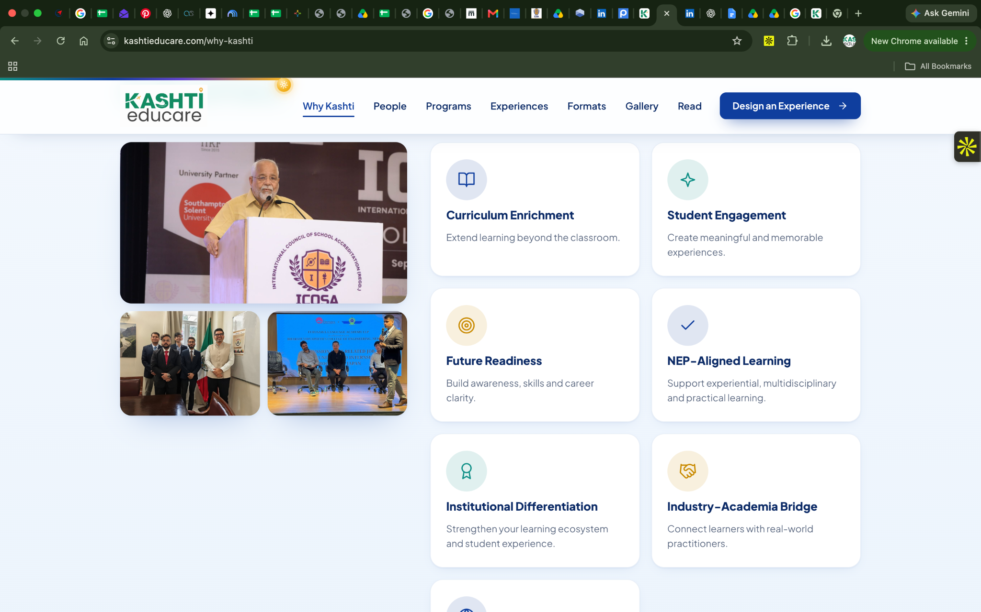
1} Can we put 3 more images to end the space below the uploaded 3 images
https://drive.google.com/drive/folders/1j5AbrBOvmfi3bQ_1oXfCrwcSrE51oC4G?usp=drive_link
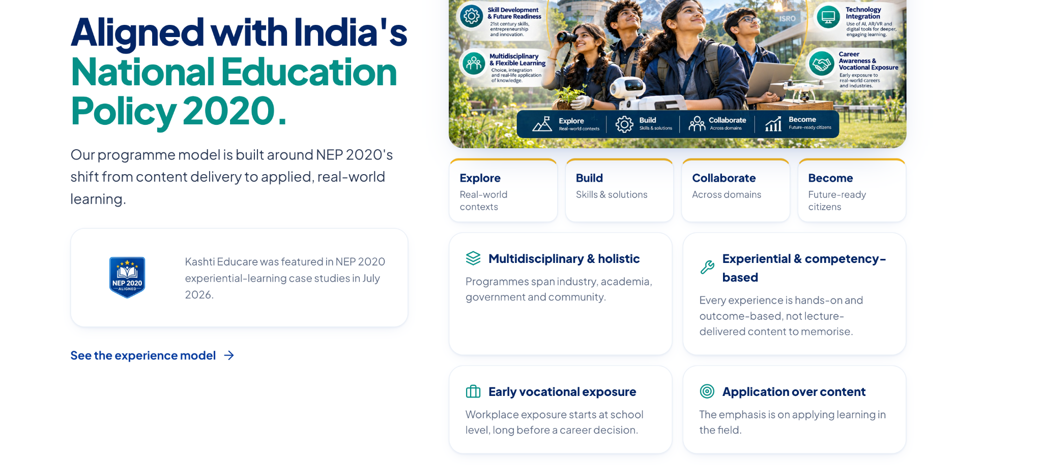
2}
- Can we please remove explore build collaborate become from the text part below the image because that is coming twice(see screenshot above) AND
- CAN WE MAKE THE CONTENT ALIGNMENT (IN THE LOWER RIGHT SECTION)
3} Institutions we've worked with
Replace this with OUR ENGAGEMENTS
3} REPLACE THE IMAGES IN THIS WITH THE ONES PASTED BELOW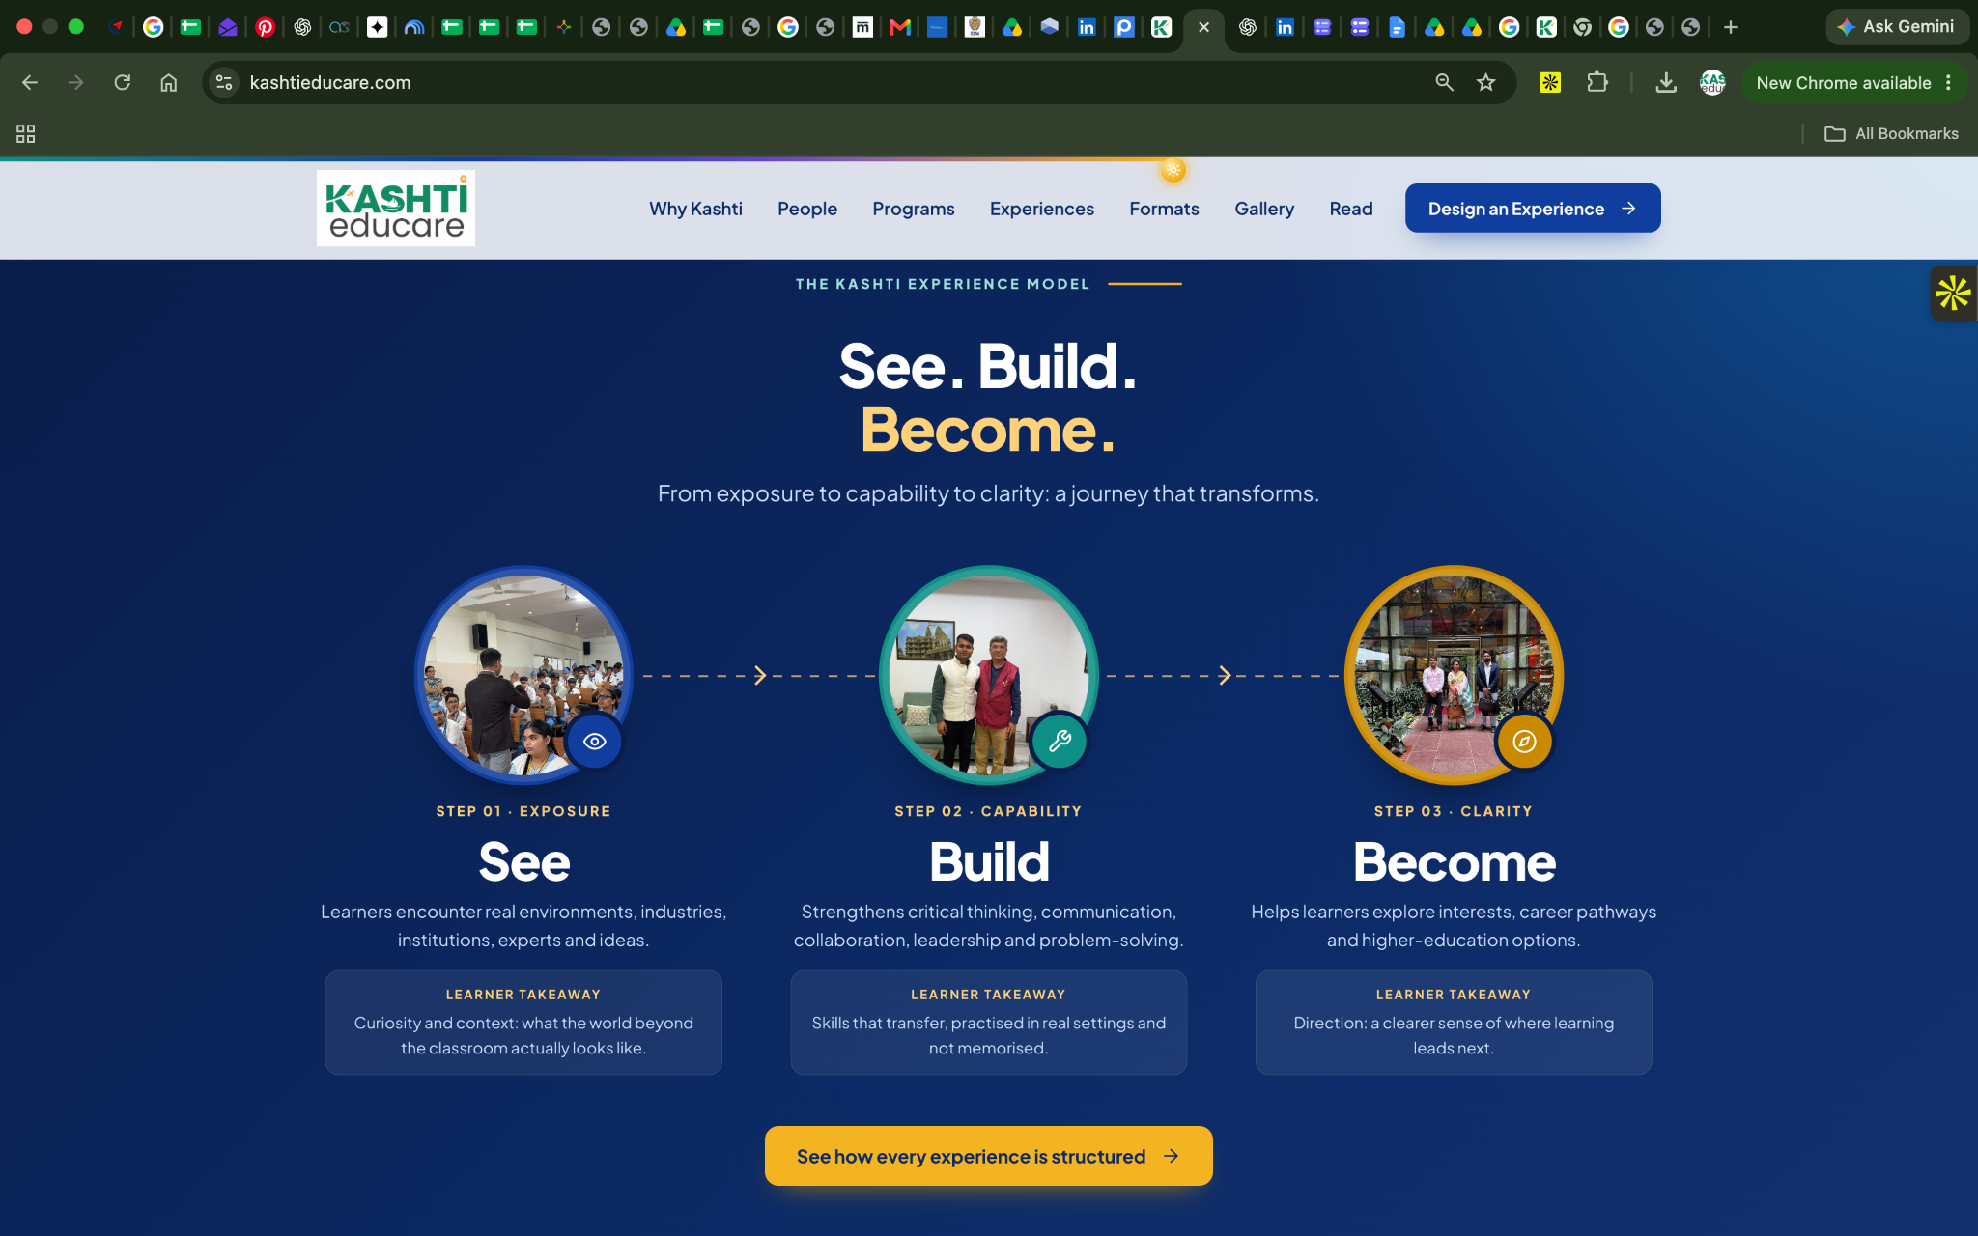

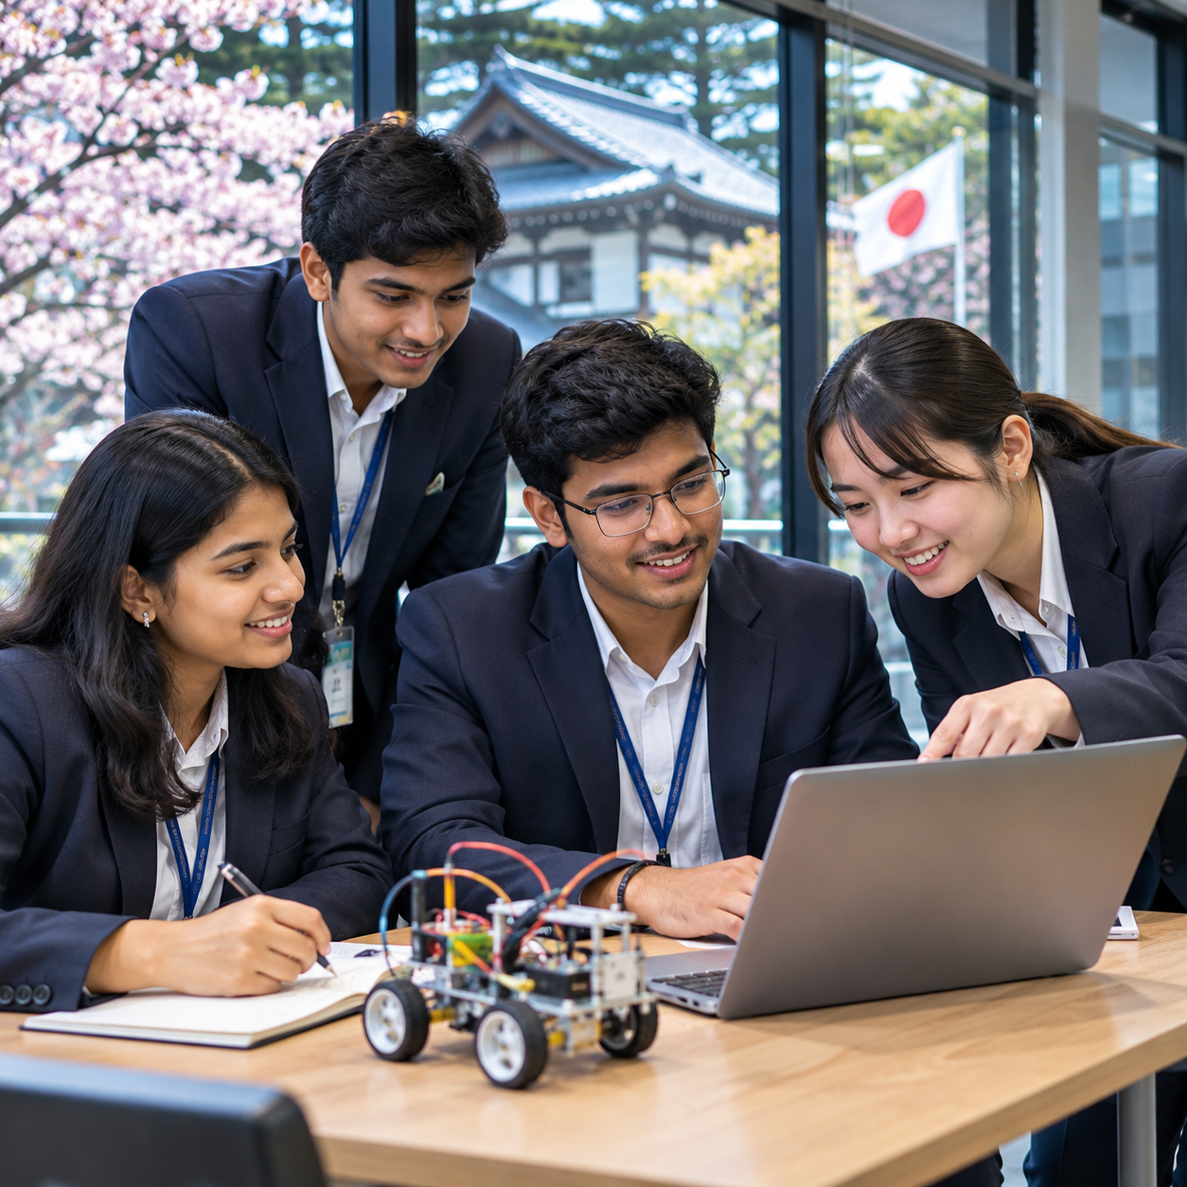

Hero section text change to:
We help institutions make curriculum enrichment calendar
Curriculum enrichment highlighted

